|  |  |  |  |  |
| --- | --- | --- | --- | --- |
| |  |  | | --- | --- | |  |  | | **Project Status Report**  Initiative-149: Rewrite LIMS Reports  As of 05/03/2022 | **Project Manager:** Shabab Shams  **Project Sponsor:** Srivi Ramamurthy |

|  |  |  |  |  |  |  |  |  |
| --- | --- | --- | --- | --- | --- | --- | --- | --- |
| **Initiative Number:** 149 | | **ETSC Priority:** N/A | | **Project Scheduled Completion Date:** 12/2021 | | | **Project Lifecycle:**  Execution | |
| **Project Description:** Rewrite LIMS Actuate Reports into Telerik Format | | | | | | | | |
| **Scope:** | **GREEN = No issues** | | **Schedule:** | | **GREEN = No issues** | **Resources:** | | **GREEN = No issues** |

|  |  |  |  |  |  |
| --- | --- | --- | --- | --- | --- |
| **Milestones** | **Start Date** | **Schedule End Date** | **Actual**  **End Date** | **% Complete** | **Actions/Comments** |
| Initiation | 01/12/2021 | 02/14/2021 | 02/14/2021 | 100% | Approved Project Charter |
| Planning | 02/15/2021 | 03/15/2021 | 03/15/2021 | 100% | Work Plan out for Review |
| Execution | 03/15/2021 | 12/31/2021 |  | **98%** |  |

**Tentative Completion Date: 05/25/2022**

**Number of Reports by Status:**

|  |  |  |  |  |
| --- | --- | --- | --- | --- |
| **COMPLETED** | **IN UAT** | **IN DEVELOPMENT** | **IN QUEUE** | **TOTAL REPORTS** |
| **76** | **0** | **1** | **0** | **77** |

|  |  |  |  |
| --- | --- | --- | --- |
| **Key Decisions** | **Decided by** | **Outcome** | **Status** |
| Add Phani Kotla as additional resource (developer) | Dan Boulger | Approved | Decided – 04/01/2021 |
|  |  |  |  |

|  |  |  |  |
| --- | --- | --- | --- |
| **Key Risks** | **Probability** | **Impact** | **Status** |
| Final report is taking more time than expected | High | High | There are two issues left (below). Vendor working on them to resolve. |
| LIMS Application version 12.9 and Oracle 12.1 both become unsupported by vendor by July 2022. | Realized | High | Report conversion in progress. Once all reports are converted to Telerik, LIMS and Oracle can be upgraded to supported version. |

|  |  |  |  |
| --- | --- | --- | --- |
| **Key Issues** | **Impact** | **Priority** | **Status** |
| No Key Issues to Report |  |  |  |

**Final Report has two issues left:**

* All results with values above the reporting limit are 12,345.

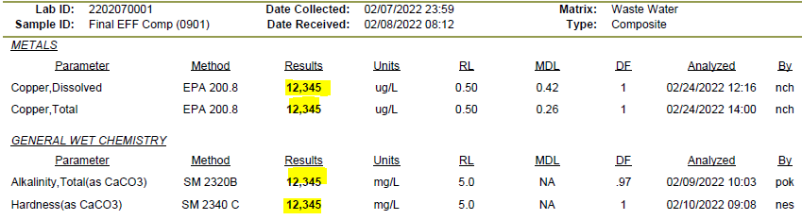

* I’m still getting too many digits for some values.  I would expect values 100+ to round to no decimals and values 10-100 to have one decimal.  Perhaps there is an error in our report rounding logic.  For some reason the RPD of 1.30 has an extra decimal as well.

